**Experiment No. 08**

**Object:**

To enable DHCP pool for generation of Dynamic Ip’s.

**Date:** March 24, 2018

# Configuration Figure:

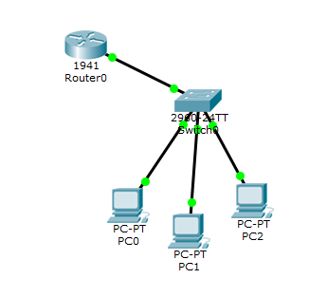

# Coding:

--- System Configuration Dialog ---

Continue with configuration dialog? [yes/no]: n

Press RETURN to get started!

Router>en

Router#conf t

Enter configuration commands, one per line. End with CNTL/Z.

Router(config)#interface gigabitEthernet 0/0

Router(config-if)#no shutdown

Router(config-if)#

%LINK-5-CHANGED: Interface GigabitEthernet0/0, changed state to up

%LINEPROTO-5-UPDOWN: Line protocol on Interface GigabitEthernet0/0, changed state to up

Router(config-if)#ex

Router(config)#ip dhcp pool 1

Router(dhcp-config)#network 192.168.2.0 255.255.255.0

Router(dhcp-config)#default-router 192.168.2.1

Router(dhcp-config)#ex

Router(config)#

Router(config)#interface gigabitEthernet 0/0

Router(config-if)#ip address 192.168.2.1 255.255.255.0

Router(config-if)#no shutdown

Router(config-if)#ex

Router(config)#

Router(config)#ex

Router#

%SYS-5-CONFIG_I: Configured from console by console

%DHCPD-4-PING_CONFLICT: DHCP address conflict: server pinged 192.168.2.1.

Router con0 is now available

Press RETURN to get started.

Router>

# DHCP mode:

